SISTER NIVEDITA MONTESSORY SCHOOL
CLASS- NURSERY
10 DAYS WORK.
PUT YOUR FINGERS AND READ-
FILE READING-
ENGLISH- CAPITAL A TO Z.
HINDI-  से  तक I
MATHS – 1 UPTO 30.
LEARN FROM FILE (FIVE 5) –
FRUITS NAME-
APPLE- , MANGO- 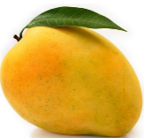, BANANA - 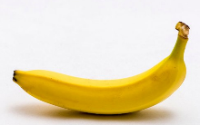
ORANGE- 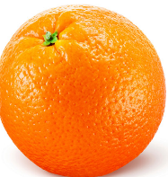, GUAVA- 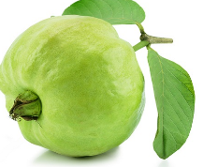, GRAPES- 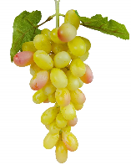

WILD ANIMALS-
LION- , TIGER- , FOX- 
ELEPHANT- 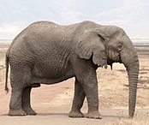 , BEAR- , DEER- 

DOMESTIC ANIMALS-
COW- 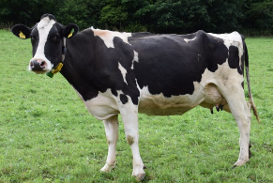, CAMEL- 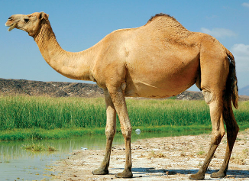, GOAT- 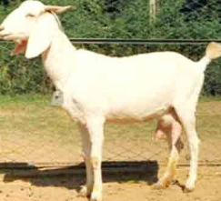
PIG- 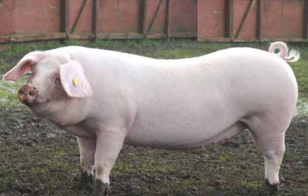 , HORSE- 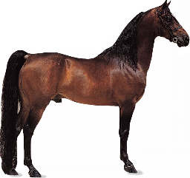, SHEEP- 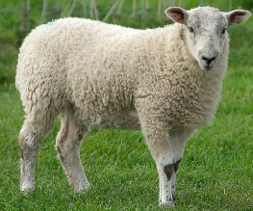

PET ANIMAL-
CAT-  , MOUSE- 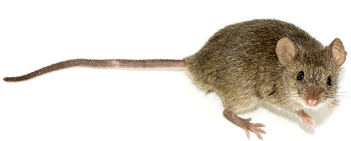, DOG- 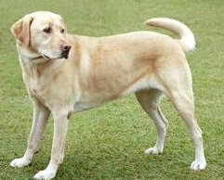
SQUIRREL- 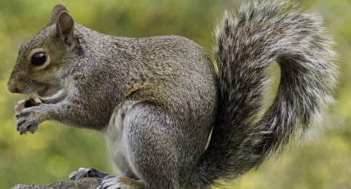 , RABBIT- 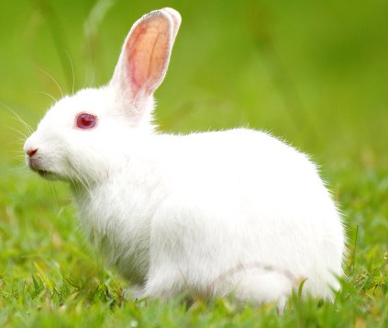

BOOK READING-0

ENGLISH – A FOR APPLE TO J FOR JUG 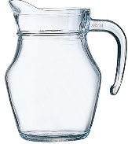

HINDI - से अनार 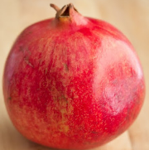 -  से अंगूर

LEARN THE QUESTION & ANSWER-
Q- WHAT IS YOUR NAME?
A – MY NAME IS …………….. .
Q- WHAT IS YOUR FATHER’S NAME?
A – MY FATHER’S NAME IS MR. ………………… .
Q- WHAT IS YOUR MOTHER’S NAME?
A – MY MOTHER’S NAME IS MRS. …………….. .
Q- HOW OLD ARE YOU?
A – I AM 3 YEARS OLD.
Q- WHERE DO YOU LIVE?
A – I LIVE IN HAZARIBAGH.

GO – OVER & COLOUR
ENGLISH-
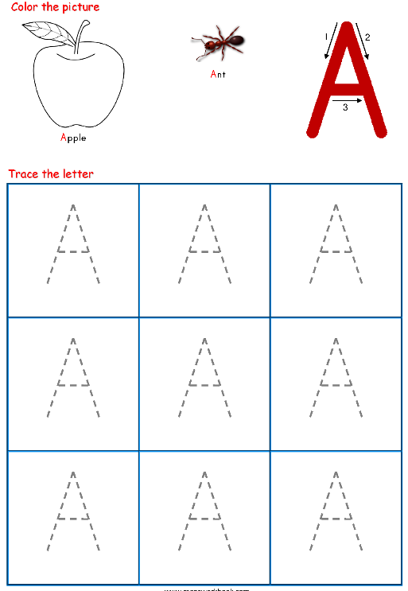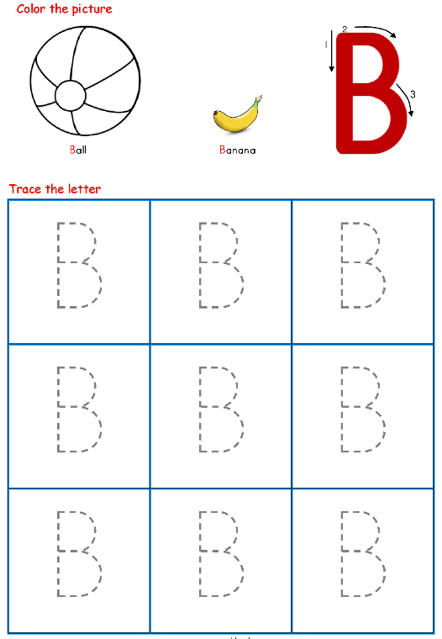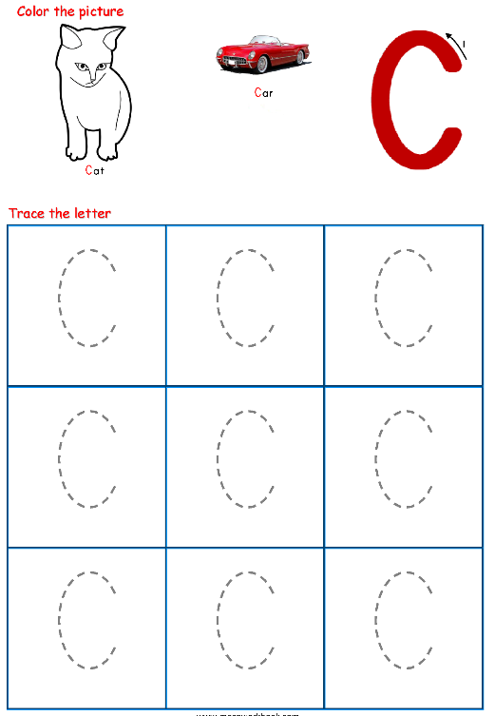
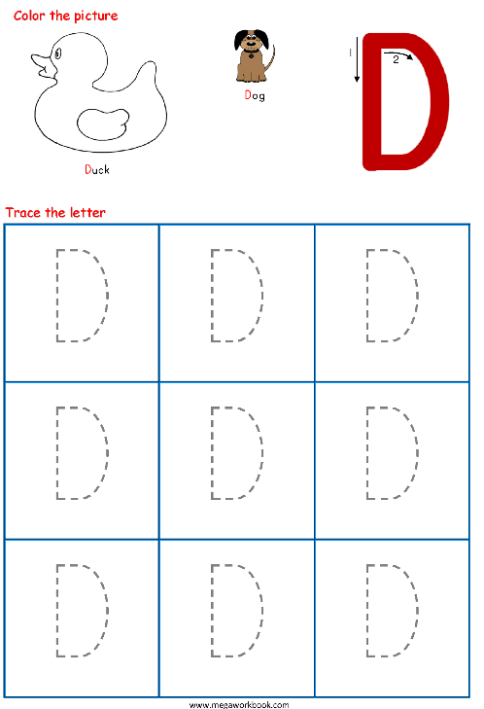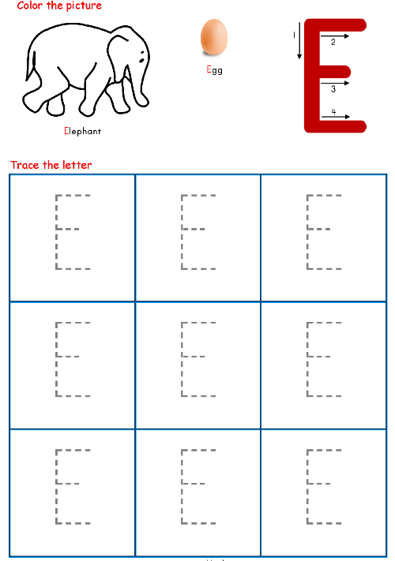

HINDI-
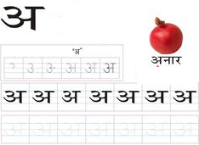
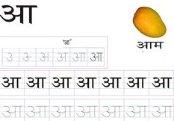
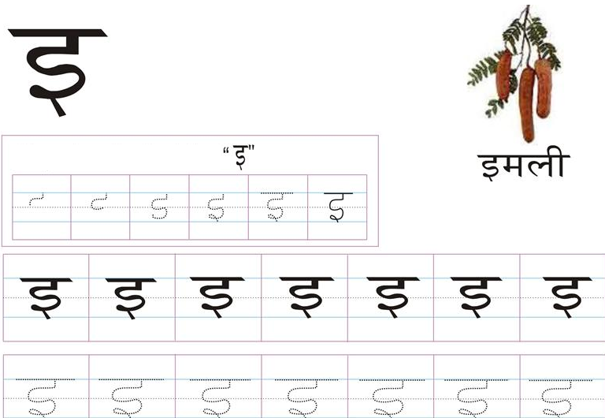
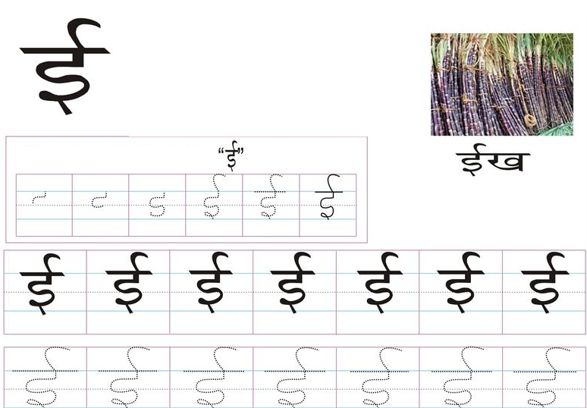

MATHS-
